Te Hoe Rorohiko

Department of Business and Digital Technologies

Student Name Julan Ray Avila Gutierrez

Student ID 99229633

New Zealand Diploma in Information Technology Technical Support (Level 5) New Zealand Diploma in Web Development and Design (Level 5)

# Database Design

DTEC502

Practical Assessment – SQL Test

Semester 1 2021

Date: **Friday, 11th June 2021**

Time: **8.00am – 10.00am**

Time Allowed: 2 hours 00 minutes Students are encouraged to read through the exam in the first ten (10) minutes and ask any questions.

Instructions:

Answer **ALL** questions.

This is an **OPEN** resources test.

Students are allowed to use their **OWN** resources.

All required files located on the DTEC502 Moodle site under the “FINAL SQL Practical Tests” tab.

**TOTAL MARKS:** 50

*Ara Institute of Canterbury and its division members reserve the right to use electronic means to detect and help prevent plagiarism.*

This test worth **25%** of the total marks for this course.

This assignment has eight (8) pages including the cover sheet.

1. Open and execute the script file **ClientOrders.sql.**
2. List only those clients that live in Dunedin.
3. List the clients whose last name begins with the letter J.
4. Which clients have a balance between $50 and $150?

## (Mark 1)

**(Mark 1)**

**(Marks 1)**

**(Marks 1)**

1. What city does our client Mary Nelson live in? **(Marks 2)**
2. Which clients have a balance below $200 and live in Dunedin?

## (Marks 2)

1. What is the difference between the clients limit and their current balance for each client? (Hint: calculate the limit field minus the balance field). Name the field you create NewBalance.

## (Marks 3)

1. What is the total price for each line of the order? (Hint: multiply the quantity by the quotedprice) Name the new field LineTotal.
2. Which client orders (Custorder) were place after 1/6/99?

## (Marks 2)

**(Marks 2)**

1. How many clients live in each city where the number of clients is more than 3?

## (Marks 3)

1. What is the total balance for each sales rep? **(Marks 2)**
2. What is the maximum balance for each city? **(Marks 2)**
3. List all of our clients and their client representatives (repref). Display the client name as one field, and the rep name as one field. **(Marks 3)**
4. List the first and last name of the clients next to their customer order (custorder) and include the date of the customers order.

## (Marks 2)

1. What are the descriptions and amount on hand of the parts that appear on orderline 1007. Show only the records for 1007 in your answer?

## (Marks 2)

1. List the description of the parts and their quoted price and quantity on each orderline. Sort by description.

## (Marks 3)

1. List the description of the parts and their quoted price and quantity on each orderline. Only display the records that have a quoted price over 200.

## (Marks 3)

1. List all orders (order ref, order date), the client name for those orders, and all part descriptions and unit prices. **(Marks 3)**
2. List all orders (order ref, order date), the client name for those orders, and all part descriptions and unit prices. Display only the records where the order date is after 10/6/99. **(Marks 3)**
3. List all orders (order ref, order date), the client name for those orders, the rep’s name, and all part descriptions. **(Marks 3)**
4. What is the total balance for each sales rep. Display the rep name as one field. **(Marks 3)**
5. Using the answer from Question 8, now display the total linetotal (sum of linetotal) for each Order (orderref). **(Marks 3)**

**Required Outputs:**

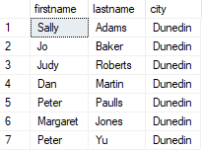**Q2.**

**Q3.**



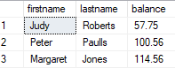**Q4.**

**Q5.**

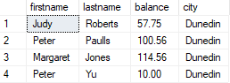**Q6.**

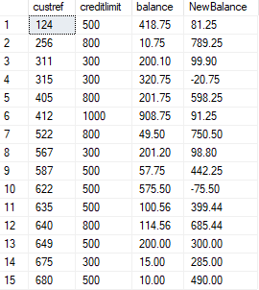**Q7.**

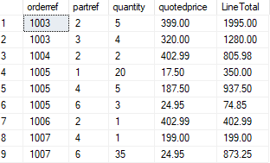**Q8.**

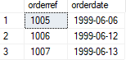**Q9.**

**Q10.**

**Q11.**

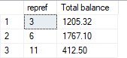

**Q12.**

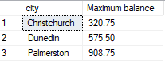

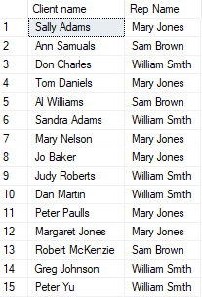**Q13.**

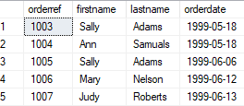**Q14.**

**Q15.**

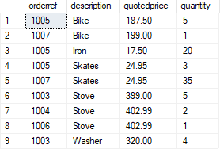**Q16.**

**Q17.**

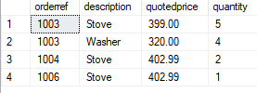

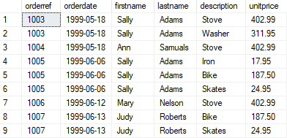**Q18.**

**Q19.**

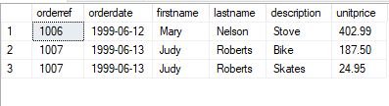

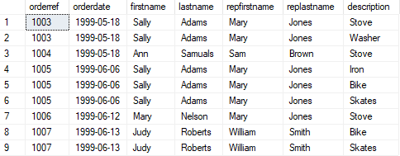**Q20.**

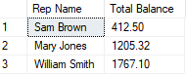**Q21.**

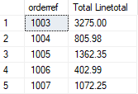**Q22.**

# MY SCRIPT

USE clientorders;

GO

--2. List only those clients that live in Dunedin.

-- (Mark 1)

SELECT

firstname,

lastname,

city

FROM client

WHERE city = 'Dunedin';

GO

--3. List the clients whose last name begins with the letter J.

-- (Marks 1)

SELECT

firstname,

lastname

FROM client

WHERE lastname LIKE 'J%';

GO

--4. Which clients have a balance between $50 and $150?

--(Marks 1)

SELECT

firstname,

lastname,

balance

FROM client

WHERE balance BETWEEN 50 and 150;

GO

--5. What city does our client Mary Nelson live in? (Marks 2)

SELECT

firstname,

lastname,

city

FROM client

WHERE firstname + ' ' + lastname = 'Mary Nelson';

GO

--6. Which clients have a balance below $200 and live in Dunedin?

--(Marks 2)

SELECT

firstname,

lastname,

balance,

city

FROM client

WHERE balance < 200

AND city = 'Dunedin';

GO

--7. What is the difference between the clients limit and their current balance for

--each client? (Hint: calculate the limit field minus the balance field). Name the

--field you create NewBalance.

--(Marks 3)

SELECT

creditlimit,

balance,

creditlimit - balance AS NewBlanace

FROM client;

GO

--8. What is the total price for each line of the order? (Hint: multiply the quantity by

--the quotedprice) Name the new field LineTotal.

--(Marks 2)

SELECT

*,

quantity * quotedPrice AS LineTotal

FROM orderline;

GO

--9. Which client orders (Custorder) were place after 1/6/99?

--(Marks 2)

SELECT

orderref,

orderdate

FROM custorder

WHERE orderdate > '1999-6-1';

GO

--10. How many clients live in each city where the number of clients is more than 3?

--(Marks 3)

SELECT

city,

COUNT(*) AS NumClients

FROM client

GROUP BY City

HAVING COUNT(*) > 3;

GO

--11. What is the total balance for each sales rep? (Marks 2)

SELECT

repref,

SUM(balance) AS repBalance

FROM client

GROUP BY repref;

GO

--12. What is the maximum balance for each city? (Marks 2)

SELECT city, MAX(balance) AS MaxBalance

FROM client

GROUP BY city;

GO

--13. List all of our clients and their client representatives (repref). Display the client

--name as one field, and the rep name as one field. (Marks 3)

SELECT

firstname + ' ' + lastname AS ClientName,

RepFirstname + ' ' + RepLastName AS RepName

FROM client C JOIN rep R

ON C.repref = R.repref;

GO

--14. List the first and last name of the clients next to their customer order

--(custorder) and include the date of the customers order.

--(Marks 2)

SELECT

orderref,

firstname,

lastname,

orderdate

FROM client C join custorder CO

ON C.custref = CO.custref;

GO

--15. What are the descriptions and amount on hand of the parts that appear on

--orderline 1007. Show only the records for 1007 in your answer?

--(Marks 2)

SELECT

orderref,

description,

onHand

FROM part P JOIN orderline O

ON P.partref = O.partref

WHERE orderref = 1007;

GO

--16. List the description of the parts and their quoted price and quantity on each

--orderline. Sort by description.

--(Marks 3)

SELECT

orderref,

description,

quotedPrice,

quantity

FROM part P JOIN orderline O

ON P.partref = O.partref

ORDER BY description;

GO

--17. List the description of the parts and their quoted price and quantity on each

--orderline. Only display the records that have a quoted price over 200.

--(Marks 3)

SELECT

orderref,

description,

quotedPrice,

quantity

FROM part P JOIN orderline O

ON P.partref = O.partref

WHERE quotedPrice > 200;

GO

--18. List all orders (order ref, order date), the client name for those orders, and all

--part descriptions and unit prices. (Marks 3)

SELECT

CO.orderref,

orderdate,

firstname,

lastname,

description,

unitPrice

FROM custorder CO JOIN client C

ON CO.custref = C.custref

JOIN orderline O

ON O.orderref = CO.orderref

JOIN part P

ON P.partref = O.partref;

GO

--19. List all orders (order ref, order date), the client name for those orders, and all

--part descriptions and unit prices. Display only the records where the order

--date is after 10/6/99. (Marks 3)

SELECT

CO.orderref,

orderdate,

firstname,

lastname,

description,

unitPrice

FROM custorder CO JOIN client C

ON CO.custref = C.custref

JOIN orderline O

ON O.orderref = CO.orderref

JOIN part P

ON P.partref = O.partref

WHERE orderdate > '1999-6-10';

GO

--20. List all orders (order ref, order date), the client name for those orders, the rep’s

--name, and all part descriptions. (Marks 3)

SELECT

CO.orderref,

orderdate,

firstname + ' ' + lastname AS ClientName,

RepFirstname + ' ' + RepLastName AS RepName,

description

FROM custorder CO JOIN client C

ON CO.custref = C.custref

JOIN rep R

ON R.repref = C.repref

JOIN orderline O

ON O.orderref = CO.orderref

JOIN part P

ON P.partref = O.partref;

GO

--21. What is the total balance for each sales rep. Display the rep name as one

--field. (Marks 3)

SELECT

RepFirstname + ' ' + RepLastName AS repName,

SUM(balance) AS repBalance

FROM rep R

JOIN client C

ON R.repref = C.repref

GROUP BY RepFirstname, RepLastName;

--22. Using the answer from Question 8, now display the total linetotal (sum of

--linetotal) for each Order (orderref). (Marks 3)

SELECT

orderref,

SUM(quantity * quotedPrice) AS LineTotal

FROM orderline

GROUP BY orderref;

GO

# My Output

# 1- 5

# 6

# 7

# 8

# 9 - 13

# 14 - 15

# 16

# 17

# 18

# 19

# 20

# 21-22